Kissing Couples
Consider some research that studied kissing couples to see if they tended to lean their heads to the right while kissing. They observed couples from age 13 to 70 in public places such as airports, train stations, beaches, and parks. They observed a total of 124 kissing couples with simple random sampling. The researchers noted that other right-sided tendencies appear in approximately two-thirds of the population. So, they wanted to test this value for the proportion of all kissing couples who turn right. However, this time they did not have a prior suspicion of whether the population proportion would be greater or smaller than 0.667. Their sample had $\hat{p}=0.645$ couples who turned to the right.
- State the null hypothesis represented by this statement.

- State the alternative hypothesis to represent that the population proportion is not two-thirds.

- Using this new hypothesized value for p, is the sample size technical condition still met?

- Compute the test statistic for this hypothesized value.

To compute a P-value for a "two-sided" (not equal to) alternative, we look for results at least as extreme (farther from the hypothesized value value p₀) as the sample result in both directions.
- For the following standard normal curve, shade the area to the left of the observed test statistic (in this problem negative), and the area to the right of the positive z-score.
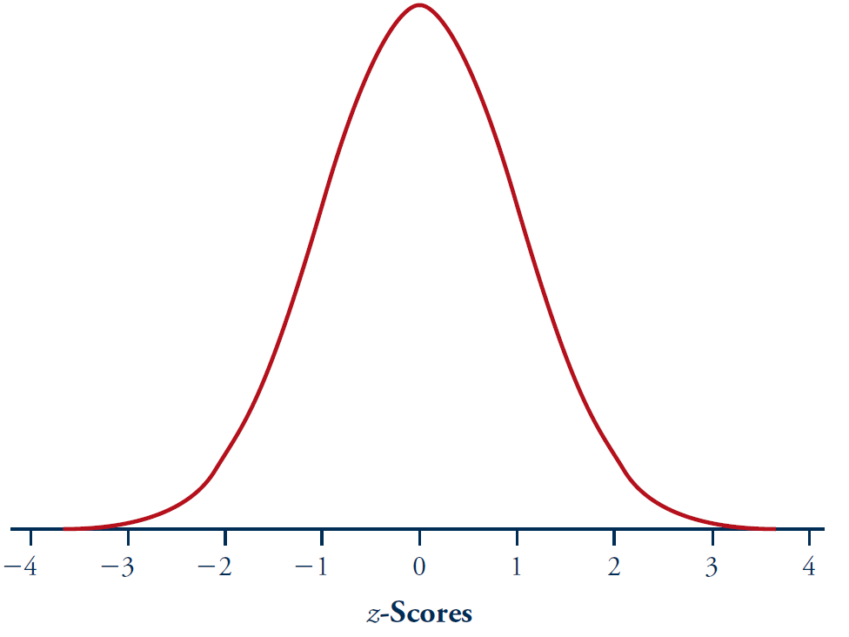
- How do these two areas compare?

- Use a z-score calculator to determine the two-sided P-value for this test. Notice it is twice the value of the one-sided P-value.

- What is your test decision at the $α=0.05$ level? Do you reject or fail to reject the null hypothesis?

- Do these data provide convincing evidence that p differs from two-thirds? Explain your reasoning, including an interpretation of what this P-value measures (what is it the probability of?).

- Determine the test statistic and P-value for testing whether the population proportion of all kissing couples differs from 0.60. State your test decision at the $α=0.05$ level and summarize your conclusion.

