Percent of Folks w/Cellphones
- Suppose a market research firm is hired to estimate the percentage of adults living in a large city who have cell phones. Five hundred adult residents are chosen in a simple random sample from the city and are surveyed to determine whether they have cell phones. Of the 500 people sampled, 421 responded yes - they own cell phones, the rest say they don’t. Using a 95% confidence level, compute a confidence interval for the true proportion of adult residents of this city who have cell phones.
- What are the sample size and sample proportion?
Use the correct notation.
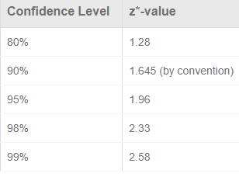

- What’s the estimated standard error of the
sample proportion?

- What is the critical value (z*)?
- What is the margin of error?
$$\hat{p}±z^{*}\sqrt{\frac{\hat{p}(1-\hat{p})}{n}}$$

- What is the confidence interval?

- Describe this CI in-context (provide a sentence, it should mention cell phones!).

- What do we mean by 95% confident?

- Another 500 people are sampled. This time, 460 of the respondents said that they owned a cell phone.
- What is the sample proportion?

- Was this result likely to happen according to our previous result?

- What do you think about your confidence interval?

- The organizers want to settle this once and for all. They want a survey done that will have only 1% margin of error with a 99% confidence level! Below, you’ll calculate the necessary sample size.
- Calculate the average of the two sample proportions. Use this as your new sample proportion.

- Write down some potentially useful math expressions related to this question’s introduction.

- From these, fill in constants you know, and attempt to solve for the unknown sample size n.

- Report your result in context.

- The city’s population is 450,000. Can we meet the technical requirements for CLT?

