
Confidence Intervals for Means
You take a SRS of students and ask them how many hours of sleep they got last night. You find a sample mean of 6.6 hrs and sample SD of 0.825 hrs. Below, you will calculate a 95% confidence interval for the average hours slept by students.
- If you assume your sample size is 10, calculate the estimated standard error for your sample distribution.
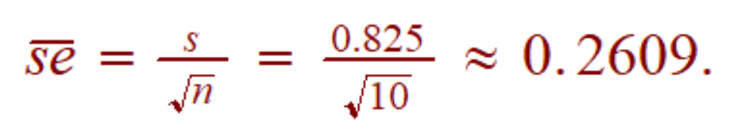
- Find your critical value ($t_{df}^{*}$). You’ll need to use the t-distr calculator (there is a link on the class GDoc).
df = 9, so for 95% confidence, we have $t_{9}^{*}=2.262$
- Calculate your confidence interval.
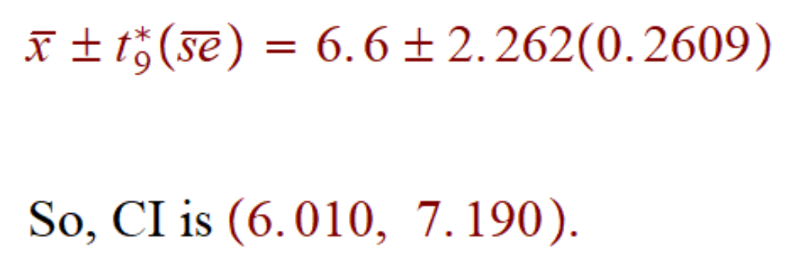
- Describe your confidence interval in context.
We are 95% confident that the average number of hours slept by students is
between 6 and 7.2 hrs.

- What do you mean by “95% confident”?
We mean that if you were to repeatedly sample this population, and create confidence intervals with each sample mean, 95 percent of those confidence intervals would include the population parameter $μ$.
- Now repeat parts a-d, but this time assume the sample size is 30.
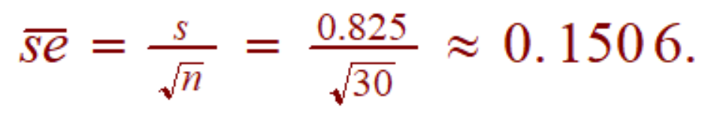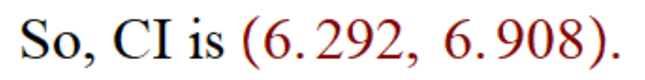
We are 95% confident that the average number of hours slept by students is
between 6.3 and 6.9 hrs.
- How did the confidence interval change when the sample size increased?
A larger sample size led to a smaller 95% CI !! Two reasons: se is smaller, and so is $t_{df}^{*}$ since we need to compensate less, w/a higher sample size.

