Critical Values for Means
- Draw a rough sketch of the t-distribution with 9 degrees of freedom.
[Hint: It should look very much like a standard normal curve.]
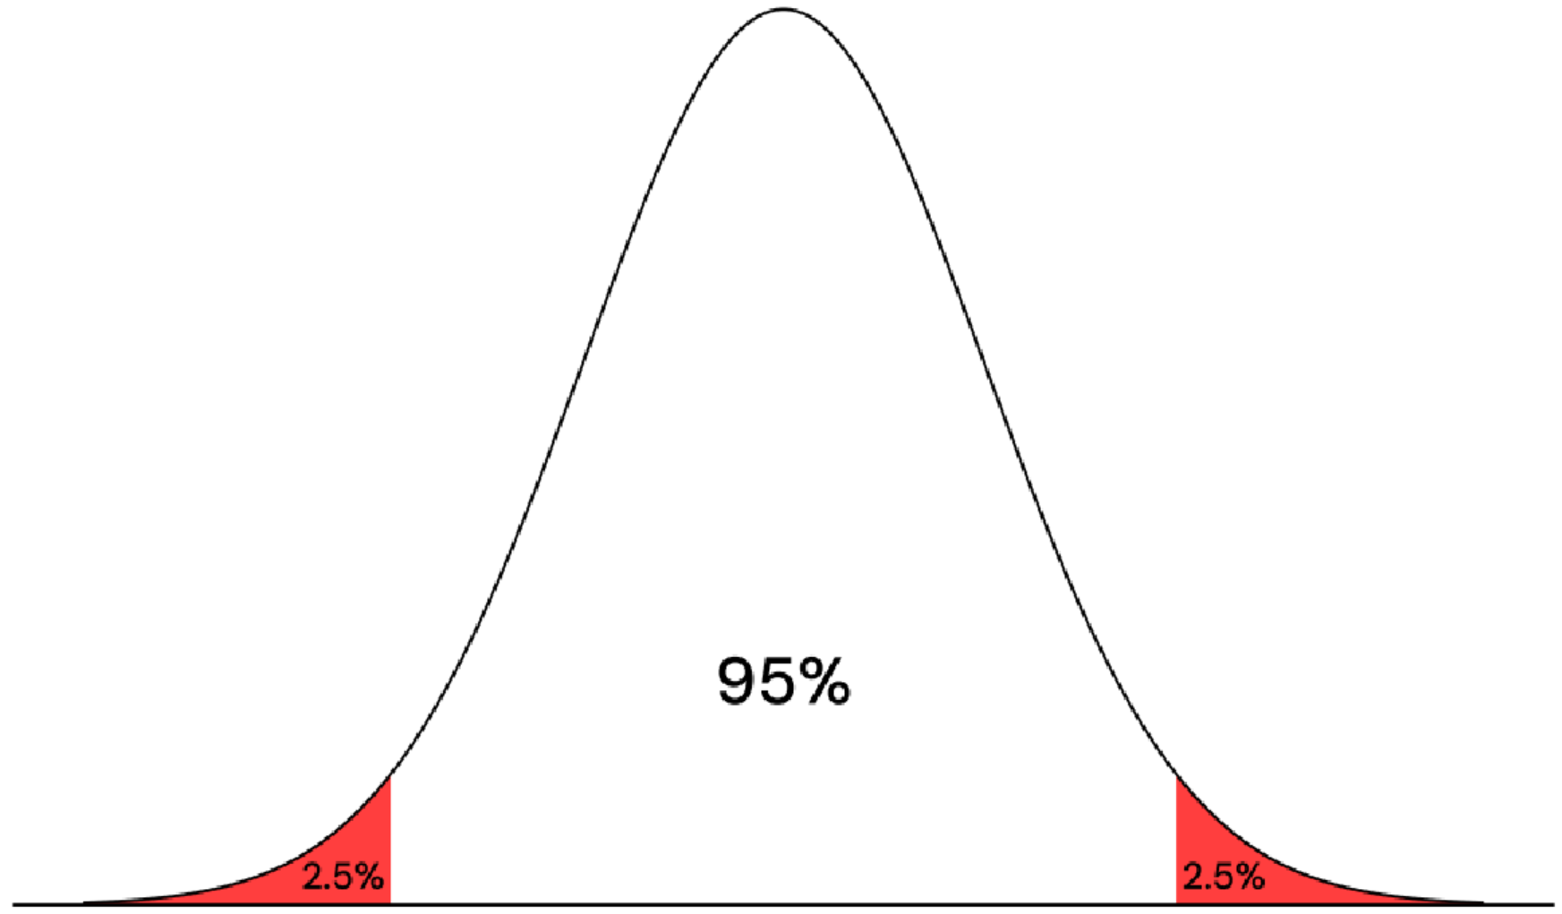
- The critical value t* for a 95% confidence interval is the value such that 95% of the area under the curve is between
t* and -t*. Shade this area on your sketch.
- What is the area to the right of t* under the curve? [Hint: This area is not 0.05.]
0.025
- Look at the t-dist Calculator (Statdistributions.com/t/) (w/two tails and p-value being the shaded area under the curve) to find the value of t* with that area to its right under a t-distribution with 9 degrees of freedom. Report this value.
t₉ = 2.263
- Is this critical value less than or greater than the critical value z* from the standard normal distribution for a 95% confidence interval? Explain why this is helpful, based on your motivation for needing the
t-distribution instead of the z-distribution.
95%: z* = 1.96 < 2.262 = t₉. This is helpful since the uncertainty from using the distribution of the sample, instead of the population, results in us needing a wider interval to ensure we capture the population mean 95% of the time.
t* greater than counterparts from the z*, reflecting greater uncertainty estimating σ with s.
Makes CIs just long enough that 95% capture value of the population mean.
- Find the critical value t* for a 95% confidence interval based on a sample size of n=20 (from the calculator). How does this value compare to the previous t* value? Explain why this is appropriate for the interval procedure as well.
[Hint: Think about whether a larger sample size would increase/decrease uncertainty in estimating σ by s.]
95%: t₁₉ = 2.093 < 2.262 = t₉. Having a larger sample size decreases the uncertainty in the dist, and therefore should be associated with a smaller interval size, which this new t-value provides.

- Find the critical value t* for a 90% and 99% confidence interval, based on a sample size of n=20.
Which is greater? Explain why this is appropriate.
90%: t₁₉ = 1.729. 99%: t₁₉ = 2.861.
99% is greater, this is appropriate since we expect it to be more likely to capture the population mean if the interval is bigger.
- Find the critical value t* for a 95% confidence interval based on a sample size of n=130.
95%: t₁₂₉ = 1.979
- How has the t* value changed as you increased the degrees of freedom by increasing the sample size?
How does t* with 129 degrees of freedom compare to z*?
The t-value decreases as you increase the sample size. Z < t₁₂₉ < t₁₉ < t₉.
When n is large, there’s a small penalty for σ in s, and so t* converges to z*. Looking up z* (calculator.net): z* = 1.96.

