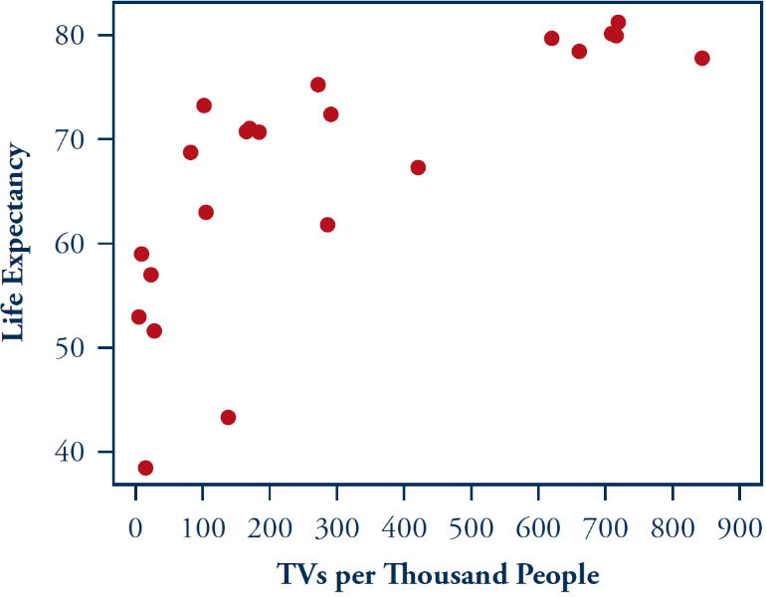
Television and Life Expectancy
Life expectancy and number of televisions per thousand people was tabulated in a sample of 22 countries, and they were reported by The World Almanac and Book of Facts in 2006. A scatterplot is reproduced here.
- Describe the direction and strength of the association between life expectancy and number of televisions per thousand people in these countries. Also comment on whether this association follows a linear form.

- Based on this scatterplot, guess the value of the correlation coefficient between life expectancy and televisions per thousand people in these countries.

- Go to “Data: TVs vs Life Expectancy” on our GoogleDoc and copy columns B and C. Paste them into “Applets: Fitting Line to Data.” Click “Use Data”, “Show Regression Line”, and “Correlation coefficient.” How accurate was your guess?

- Would you say the value of the correlation coefficient is fairly high, even though the association between the variables is not linear?

- Does the high value of the correlation coefficient provide evidence of a cause-and-effect relationship between number of televisions and life expectancy? Explain.

Take-Aways
- The correlation coefficient measures the degree of linear association between two quantitative variables. But even when two variables display a nonlinear relationship, the correlation between them still might be quite close to +/-1. With these data, the relationship is clearly curved and not linear, and yet the correlation is still close to +/-1. Do not assume from an extreme correlation coefficient that the relationship between the variables must be linear. Always look at a scatterplot, in conjunction with the correlation coefficient, to assess the form (linear or not) of the association.

- No matter how close a correlation coefficient is to +/-1, and no matter how strong the association between two variables, a cause-and-effect conclusion cannot necessarily be drawn from observational data. There are far more plausible explanations for why countries with lots of televisions per thousand people tend to have long life expectancies. For example, the technological sophistication of the country is related to both number of televisions and life expectancy (explanatory & response), so this is a confounding variable.

