Marriage Ages 2
A student investigated whether people tend to marry spouses of similar ages and whether husbands tend to be older than their wives. He gathered data on the ages of 24 couples, taken from marriage licenses filed in Cumberland County, Pennsylvania, in June and July of 1993
(Data is found on our class Google doc under Data: MarriageAges):
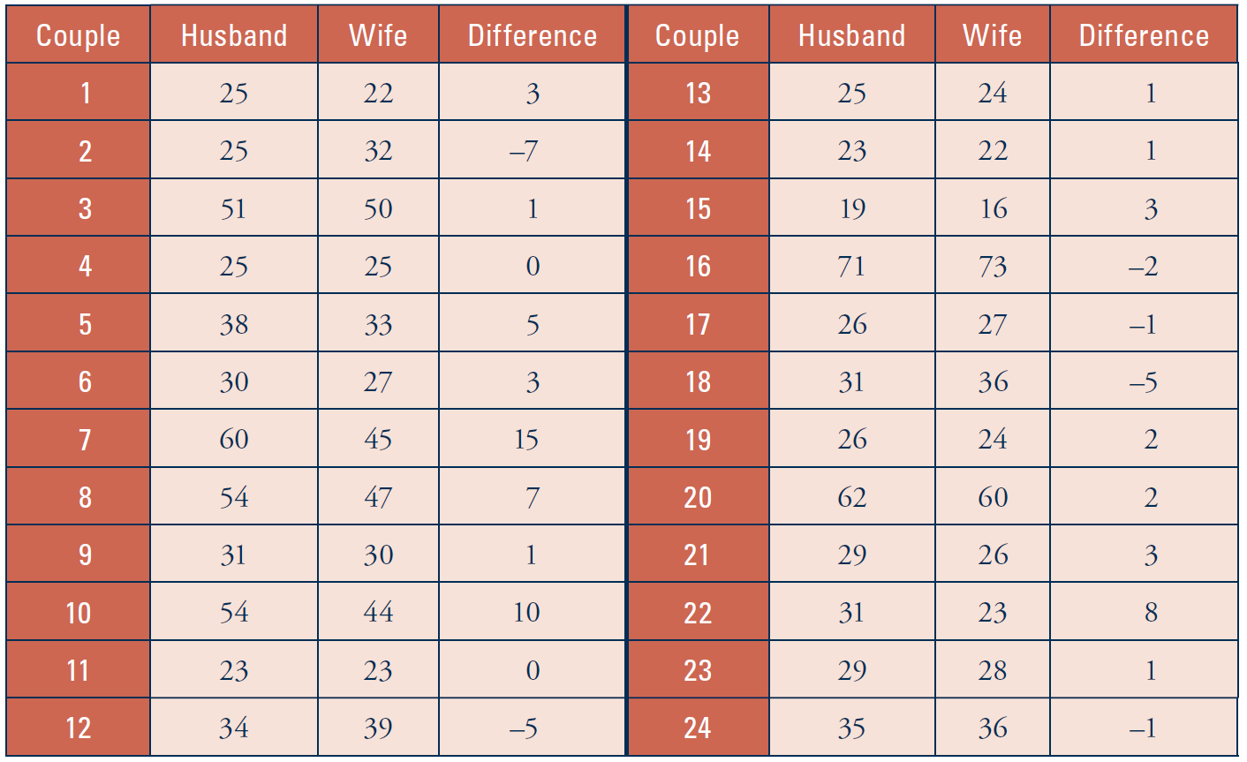
- Consider the Age Differences. Enter them into Excel. Sort the values
(Select the values, then “Data” Menu ->”Sort”->OK) and determine their IQR.
- What is the five number summary? (Hint: to calculate median: “=Median()”)

- Are there any outliers in your data set? If so, identify them. Show your work.

- Below, create an (unmodified) box plot to display this data.

