Marriage Ages
A student investigated whether people tend to marry spouses of similar ages and whether husbands tend to be older than their wives. He gathered data on the ages of 24 couples, taken from marriage licenses filed in Cumberland County, Pennsylvania, in June and July of 1993
(Data is found on our class Google doc under Data: MarriageAges):
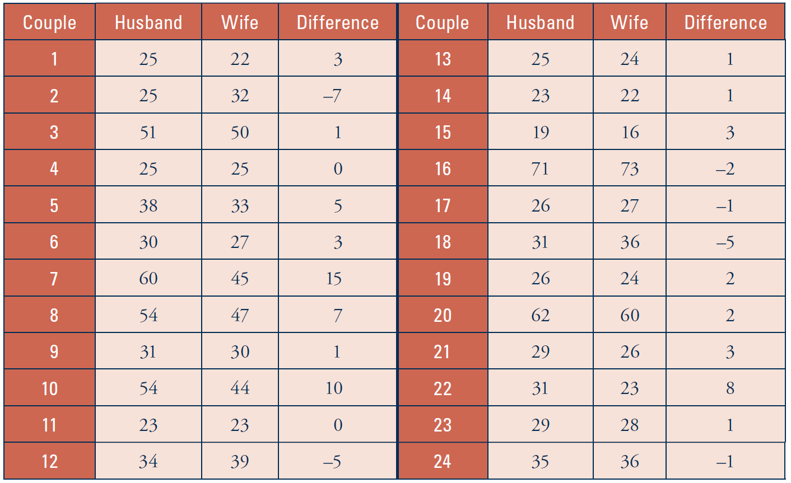
- Using technology (Excel), calculate the median (MEDIAN) and mean (AVERAGE) age for the husbands. Then find these for the wives. Which spouse tends to be older and by how many years on average?

- Using technology to sort the values (Select the values, then “Data” Menu ->”Sort Range”) and determine the IQR and standard deviation (STDEV) of ages for each group. Does one group of spouses have more variability in their ages than the other group?

- Comment on how the age distributions compare, citing numerical summaries for support.

- Notice that the table also reports the difference in ages, subtracting the wife’s age from the husband’s age, for each couple. Calculate the mean and median of these age differences for the two groups. Do you notice anything about how these compare to the means and medians of the husbands and wives individually?

- Calculate the IQR and standard deviation of these age differences. Compare these values to the IQR and standard deviation of the ages themselves in part b.

- Determine how many and what proportion of the age differences fall within one standard deviation of the mean. Is this close to the percentage that the empirical rule predicts?

- What do these calculations reveal about whether or not people tend to marry spouses of similar ages? Explain.

- Based on the context, explain why the age differences have much less variability than the individual ages.

