Ice Cream Calories
Food products are required by law to provide nutritional information on their labels, and many companies post such data on their websites. Data on calorie amounts per serving can be found at (bit.ly/introstatsdata) under “Data: IceCream”. There you will find info for various flavors of Ben & Jerry’s, Cold Stone Creamery, and Dreyer’s ice cream. A few (but not all!) of these values are listed alphabetically below.
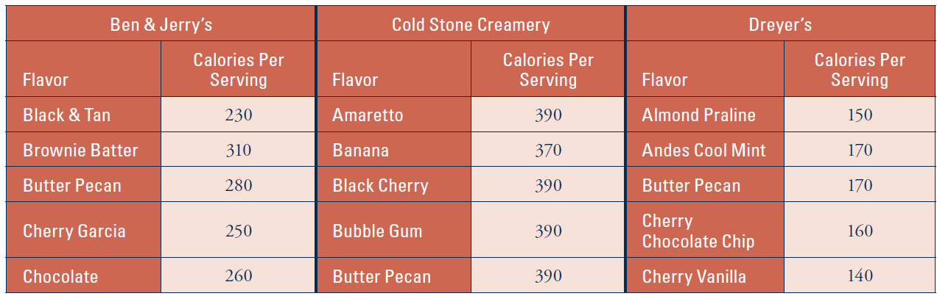
- Use technology to calculate the five-number summary of the calorie amounts for ALL flavors in each brand. Use “Applets: Dotplots” at bit.ly/introstatsdata. There, you will be able to cut/paste in the data from “Data: IceCream.” Paste them one company at a time. After each, click “Use Data.” Then you can click the “Actual” check boxes for “Mean”, “Median”, and “IQR”. This will give you access to the 5 numbers. In particular, the upper and lower quartiles will be seen in blue, to the right of the graph, as part of the IQR calculation. Report these in the following table:
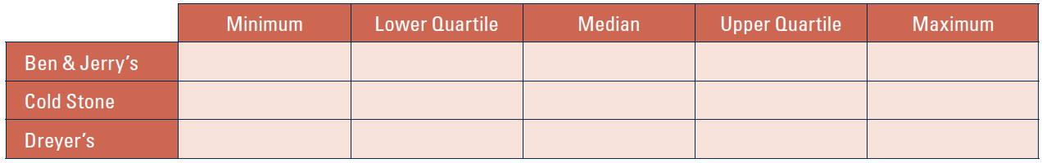
- Click “Add Boxplot” and “Show outlier” to construct (modified) boxplots of the distribution of calorie amounts for the three brands. Reproduce them blow, but on the same axis for comparison. Discuss how the three brands’ calorie amounts compare, based on these boxplots.

- Can you speculate about a possible problem with making comparisons of calorie amounts among the three brands based on these data? [Hint: You were not given a particularly relevant piece of information regarding “servings” at the beginning of the activity.]

Five-number summaries and boxplots can be useful for making comparisons. There is one important problem with the previous analysis, though. Ben & Jerry’s and Dreyer’s both consider a serving to be ½ cup of ice cream, so their calorie amounts are directly comparable. But Cold Stone Creamery considers a serving to be 170 grams.
- How could you adjust for this discrepancy (in principle, anyway)?

One difficulty with converting these calorie amounts to a common serving size is that ½ cup is a measure of volume and 170 grams is a measure of mass. The conversion is, therefore, not as simple as, say, converting inches to centimeters (both measures of length). The website (InchCalculator.com/convert/cup-to-gram) has a “gram conversion calculator” that applies to individual food items. Gourmetsleuth.com suggests that the conversion rate for ice cream is roughly 131 grams per cup.
- How would you use this conversion information to convert Cold Stone’s calorie amounts to a “per half cup” amount, comparable to Ben & Jerry’s and Dreyer’s?

