Rollercoaster Boxplots
The following boxplots display the distributions of top speeds (in miles per hour) for roller coasters in the United States, classified by whether the coaster is wooden or steel:
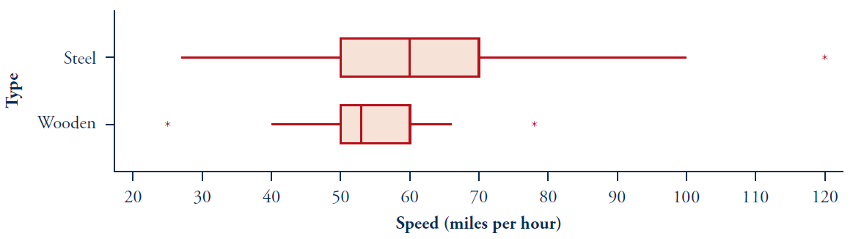
Observational unit:
Explanatory variable: Type:
Response variable: Type:
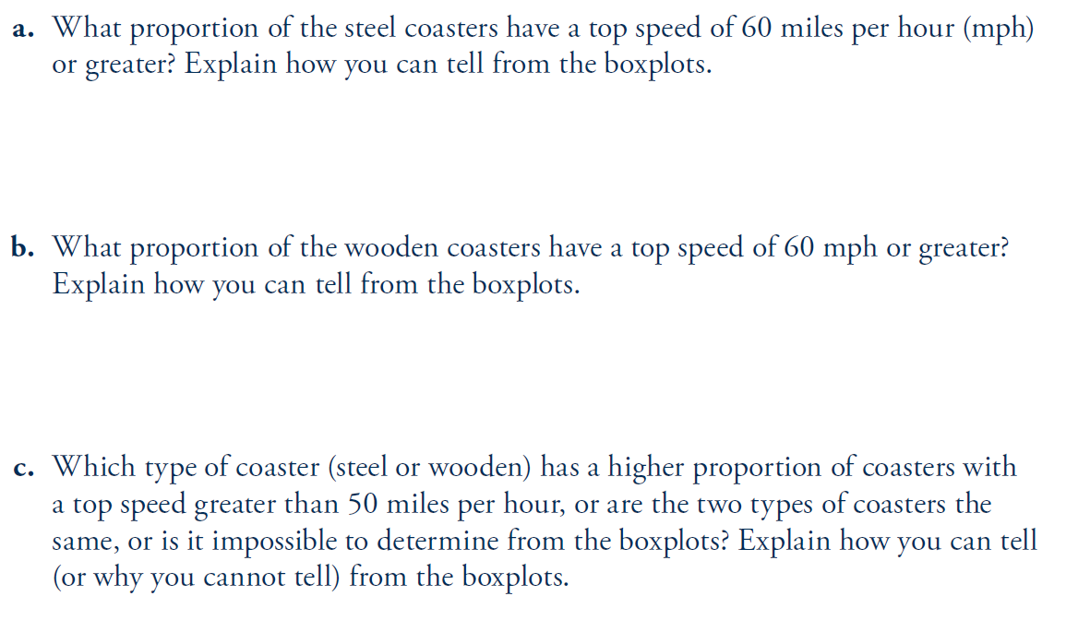
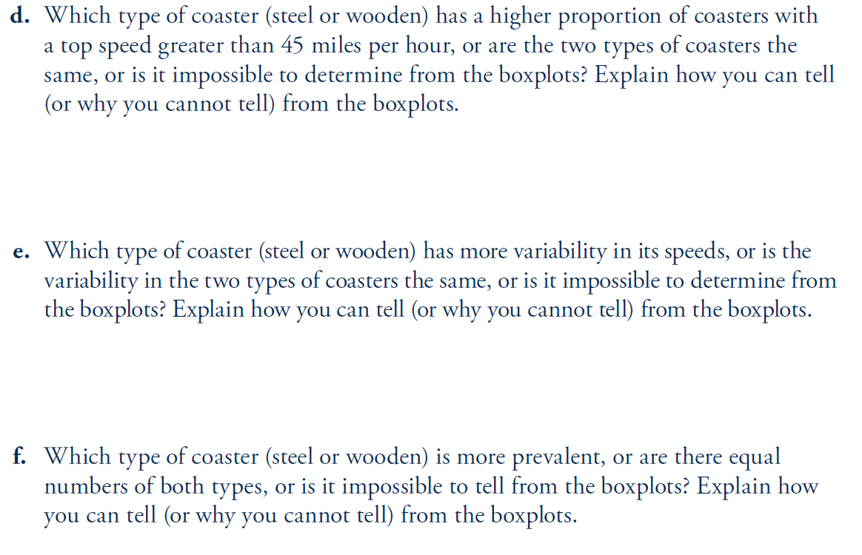
Build a boxplot for these five number summaries on the chart below (use a straight edge for your range):