Placement Exam Scores
Scores were gathered on a mathematics placement exam consisting of 20 questions taken by n = 213 students. The frequency table is reproduced below. The mean score on this exam is x̄ = 10.221 points. The standard deviation of the exam scores is s = 3.859 points. 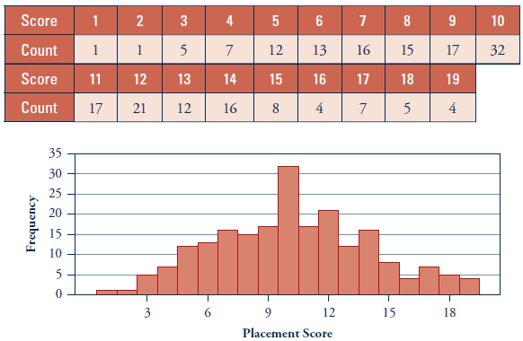
Is this a histogram or bar chart? How can you tell?
Bar chart since the bars are touching, the vertical bar shows frequency, and the horizontal axis is quantitative, not categorical.
- Does this distribution appear to be roughly symmetrical and mound-shaped?
Mound-shaped.
- What placement scores are within one standard deviation of the mean?
Mean – SD = 10.221 - 3.859 = 6.362
Mean + SD = 10.221 + 3.859 = 14.08
- How many students had a score within one standard deviation of the mean?
146 (notice we don’t include a score of 6)
- What is the proportion of students within one standard deviation of the mean? 146/213 = 0.6854

- What about within TWO standard deviations of the mean?
Mean – 2 x SD = 2.503
Mean + 2 x SD = 17.939
(Hint, it’s faster to find which scores DON’T and subtract from the student total of 213)
Number of scores: 11
Proportion of total scores: 202/213 = 0.948

- What about within THREE standard deviations of the mean?
Mean – 2 x SD = -1.356
Mean + 2 x SD = 21.798
(Hint, it’s faster to find which scores DON’T and subtract from the student total of 213)
Number of scores: 213
Proportion of total scores: 213/213 = 1

- Do you think the 68-95-99.7 empirical rule would work well for a dataset with an irregular distribution?
Why or why not?
Extreme outliers (e.g, when looking at income, billionaires are outliers) cause the standard deviation to be large and the mean to be misleading. As a result, far more than 0.3% of people fall outside three standard deviations because of the long right tail in income distribution.
