Great Country Life Expectancy
- What is the mean of the following data?
- Fill in this form to determine its standard deviation.
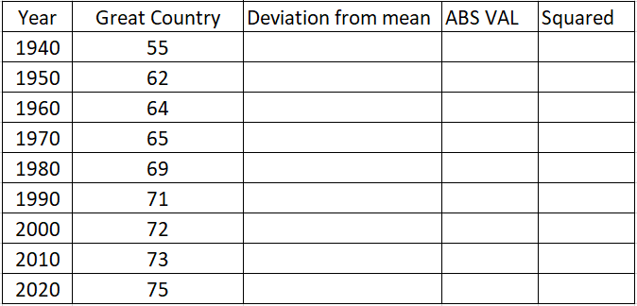
- What is the standard deviation for life expectancy in Great Country?
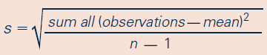

- What is the mean of the following data?
- Fill in this form to determine its standard deviation. 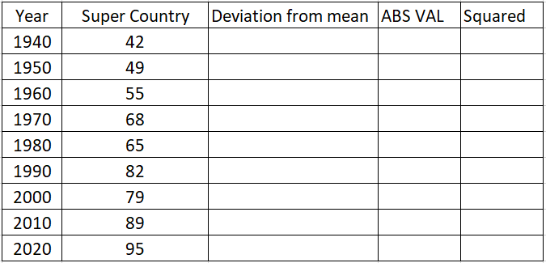
- What is the standard deviation for life expectancy in Super Country?

What if I mistyped and accidentally created an outlier?
- Which measure(s) of center are resistant to outliers?

- Which measure(s) of spread are resistant to outliers?

