Life Expectancy
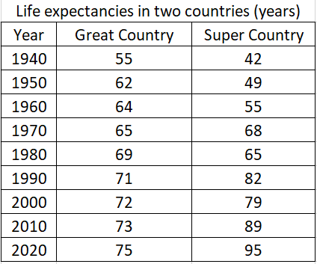
- Report the largest and smallest life expectancy values
for Great Country and calculate the difference.
Largest: Smallest:
Difference:

- Report the largest and smallest life expectancy values
for Super Country and calculate the difference.
Largest: Smallest:
Difference:

- Which country has the larger range?

- Determine the lower quartile of life expectancies for Great Country:
(the median of the four values BELOW the median)

- Determine the upper quartile of life expectancies for Great Country:
(the median of the four values ABOVE the median)

- Determine the interquartile range (IQR) for Great Country:
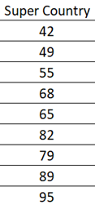

- Determine the lower quartile of life expectancies for Super Country:
(the median of the four values BELOW the median)

- Determine the upper quartile of life expectancies for Super Country:
(the median of the four values ABOVE the median)

- Determine the interquartile range (IQR) for Super Country:

- Which country has the larger IQR?

