Politician Speaking Speeds
Speaking speeds (# of words divided by # minutes spoken) by GOP and Dem presidential candidates in early debates, Sept&Oct 2007, followed by side-by-side stemplots.
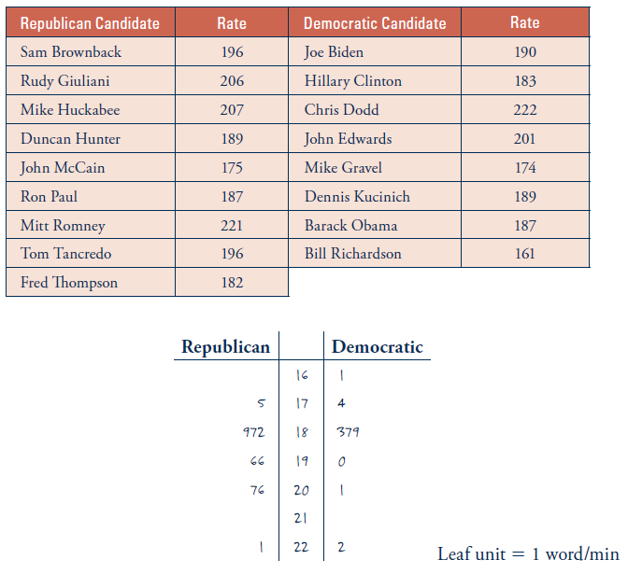
- What are the observational units?
Explanatory variable: Party affiliation Type: Categorical - Binary
Response variable: Speaking Speed Type: Quantitative
- How would you compare the CENTERS of these two distributions of speaking speeds?
Observe that they both have maximums around the 180s. However, the Democrats have more candidates less than the 180s, and fewer candidates more than the 180s. Therefore, Republicans center is higher than the Democrats.
- Calculate the MEAN of the speeds for the Republican and Democratic candidates.
Democratic: $\frac{161+174+183+187+189+190+201+222}{8}≈188.4$
Republican: $\frac{175+182+187+189+196+196+206+207+221}{9}≈195.4$
How do the means compare? The Republicans mean speed is higher than the Democrats.

- Determine the MEDIAN of the speeds for the Republican candidates (odd or even # of values?):
196

- Determine the MEDIAN of the speeds for the Democratic candidates (odd or even # of values?):
188

- How do the medians compare?
The Republicans median speed is higher than the Democrats.
- Are the values of the means similar to the values of the medians for both parties?
Yes.

- Comment on where the eventual nominees of Obama and McCain fell relative to the mean and median speaking speeds.
McCain was notably slower as a speaker than his fellow Republican candidates, but Obama spoke at a pace similar to his fellow Democratic candidates.

- Can we calculate the center for categorical variables? Why or why not?
No. Since the categorical variables aren’t numerical in nature, we have no ability to average the values.

