Partisan Speaking Speeds
(# of words divided by # minutes spoken)
Below, you’ll find a table of the speaking speeds of GOP and Dem presidential candidates in early debates (Sept & Oct 2007), followed by side-by-side stemplots.
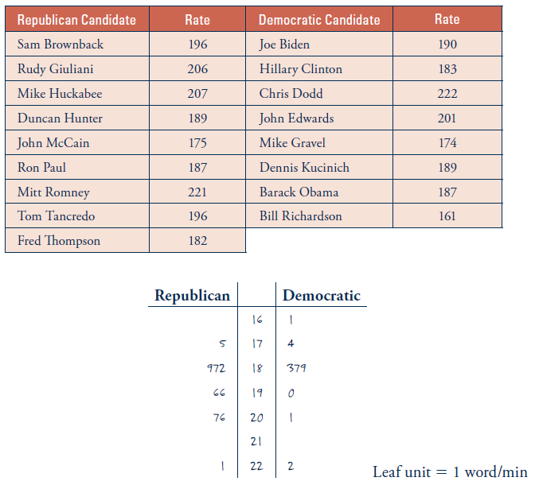
- What are the observational units?
Explanatory variable: Type:
Response variable: Type:

- Visually, how would you compare which distribution had faster speaking speeds?

- Calculate the MEAN of the speeds for the Republican and Democratic candidates.
Democratic: Republican:
How do the means compare?

- Determine the MEDIAN of the speeds for the Republican candidates (odd or even # of values?):

- Determine the MEDIAN of the speeds for the Democratic candidates (odd or even # of values?):

- How do the medians compare?

- Are the values of the means similar to the values of the medians for both parties?

- Comment on where the eventual nominees of Obama and McCain fell relative to the mean and median speaking speeds.

- Can we calculate the center for categorical variables? Why or why not?

