Population Growth in the USA
- The population of the United States grew by 9.1% between 2000 and 2009. The following
table reports the percentage growth in population for each of the 50 states during this
decade. States are classified by whether they are east or west of the Mississippi River:
- Consider the western states. Would it be reasonable to use 0.1 as the leaf unit?
Explain. [Hint: How many stems would there be? How many leaves would be on each stem?]

- Still considering the western states, would it be reasonable to use 1 as the leaf unit? Explain.

In creating stemplots, it is most effective to have approximately 4–15 stems. Having too many stems may make it difficult to see the overall pattern (e.g., clustering). Too few stems and important details can be lost because the data are clumped together without showing much pattern (e.g., gaps, skewness). One way to change the level of detail displayed is to create a split stemplot where each stem appears twice, the 0–4 leaves appear on the first stem and the 5–9 leaves appear on the second. When you want fewer stems, you can truncate the last digit in the data values or display two-digit leaves.
- If we create a split stemplot for the western states, how many stems will we have?

To investigate whether eastern or western states tend to have higher population growths, you want a display that helps directly compare the two groups. In a side-by-side stemplot, a common set of stems (for example, the ones digit) is placed in the middle of the display with leaves (for example, the tenths digit) branching out in either direction to the left and right. The convention is to order the leaves from the middle out from least to greatest.
- Complete the following side-by-side stemplot to compare the distributions of population growth between eastern and western states by filling in the states beginning with the letter N. [Hints: Use the stems provided here. An underscore (_ ) indicates where you should fill in a leaf value. Use single digit stems by truncating the tenths digit after the decimal point. So, Virginia’s percentage appears as 1|1 ignoring the 0.4.]
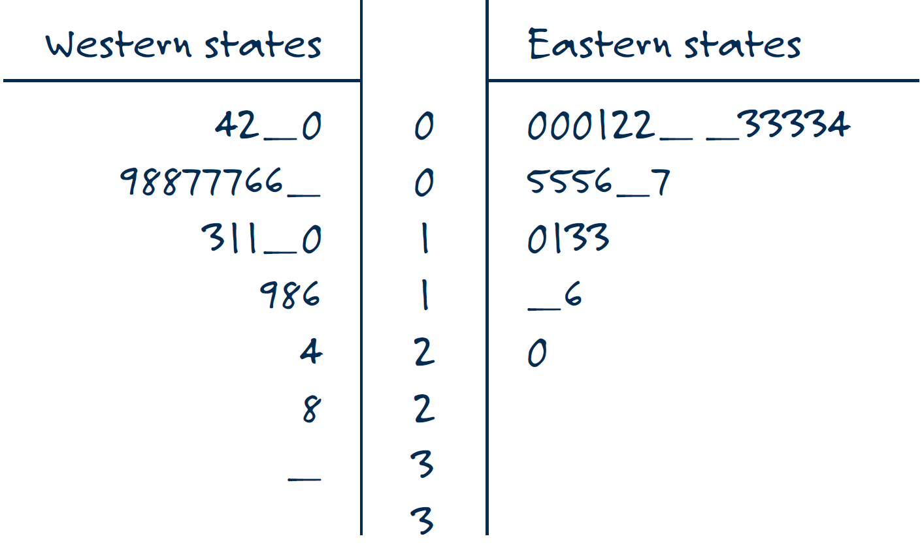
Leaf unit = one percentage point
- Based on this side-by-side stemplot, compare the distributions of population growth between eastern and western states. [Hint: Remember to comment on center, spread, shape, and any other apparent features, such as outliers, identifying the unusual states by name.]

