Handwashing
In August of 2005, researchers for the American Society of Microbiology and the Soap and Detergent Association monitored the behavior of more than 6300 users of public restrooms. They observed people in public venues such as Turner Field in Atlanta and Grand Central Station in NYC. They found that 2393 of the 3206 men washed their hands, compared to 2802 of 3130 women.
- What proportion of men washed their hands? What proportion of women?

- Are these proportions consistent with the following pair of bar graphs?
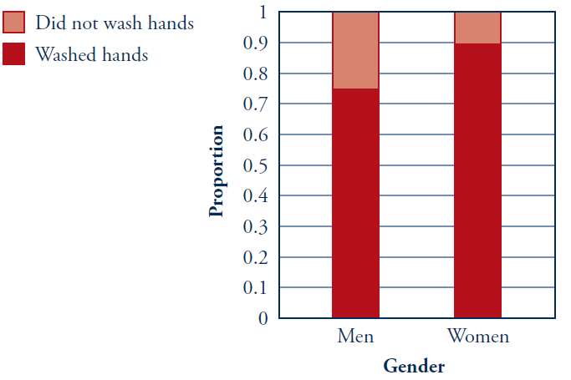
- Comment on what your calculations and the bar graph reveal about whether one gender is more likely to wash their hands after using a public restroom.

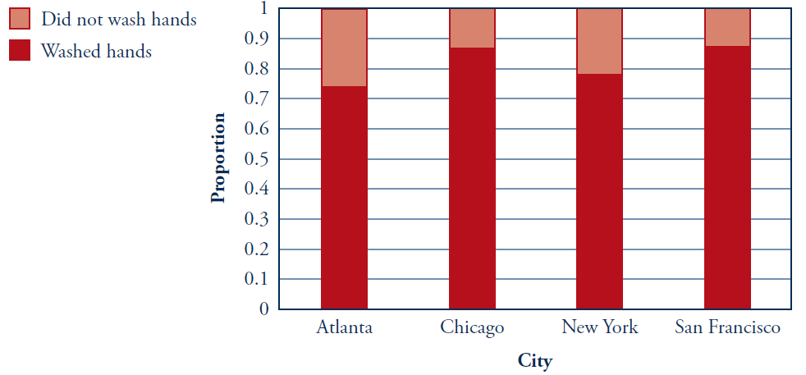
The following bar graphs reveal the distribution of the “washed hand” variable based on the city in which the person was observed.
- For each city, estimate the proportion of people who washed their hands, as accurately as you can, from the graph:
Atlanta:
Chicago:
New York:
San Francisco:

- Comment on what the bar graph reveals about how these cities compare regarding handwashing.

